EXPLORATORY DATA ANALYSIS
Market Clustering by Vegetable Zone
Sri Lanka Vegetable Price Prediction Project

Dataset | Final Combined Data (final.csv)
Time period | 2013 – 2019 (weekly)
Markets | 14 retail markets across Sri Lanka
Vegetable zones | UP Country (6 vegetables) and LOW Country (6 vegetables)
Methods used | Pearson correlation, hierarchical clustering (Ward linkage), K-Means, elbow method
Purpose | Group retail markets by price behaviour — separately for UP Country and LOW Country vegetables

1. Introduction
This report presents the findings of an Exploratory Data Analysis (EDA) focused on grouping Sri Lankan retail vegetable markets based on how similarly their prices move over time. The analysis is done separately for UP Country vegetables and LOW Country vegetables, because these two zones have fundamentally different supply chains, growing environments, and transport networks.

UP Country vegetables — such as Carrots, Leeks, and Cabbage — are grown in the central highlands at high altitude. LOW Country vegetables — such as Brinjals, Ladies Fingers, and Snake Gourd — are grown in lowland areas close to many of the major markets.

By running the clustering separately for each zone, we can find out which markets behave similarly when it comes to highland produce and whether the same groupings hold for lowland produce.

2. Data Preparation
The dataset was split into two subsets based on the vegetable_zone column. Each subset was then reshaped into a weekly price pivot table — rows represent weeks and columns represent the 14 markets. The value in each cell is the average retail price for that zone's vegetables in that market during that week.

UP Country vegetables | Beetroot, Cabbage, Carrot, Green Beans, Leeks, Tomatoes
LOW Country vegetables | Ash Plantains, Brinjals, Green Chillies, Ladies Fingers, Pumpkin, Snake Gourd
UP Country records | Approximately 30,576 rows
LOW Country records | Approximately 30,576 rows
Missing values | Handled using forward fill then backward fill per market column

3. Market Correlation Analysis
Pearson correlation was calculated between every pair of markets separately for UP Country and LOW Country vegetables. The correlation value tells us how similarly two markets' prices move over time — a value close to 1.0 means the two markets move almost identically week by week.

3.1 UP Country Correlation
For UP Country vegetables, most market pairs show high correlation in the range of 0.87 to 0.97. The strongest pairs are Colombo–Meegoda (0.97), Anuradhapura–Dambulla (0.97), and Kandy–Colombo (0.97). Badulla consistently shows the lowest correlations with all other markets, with its weakest link being Thambuththegama (0.82).

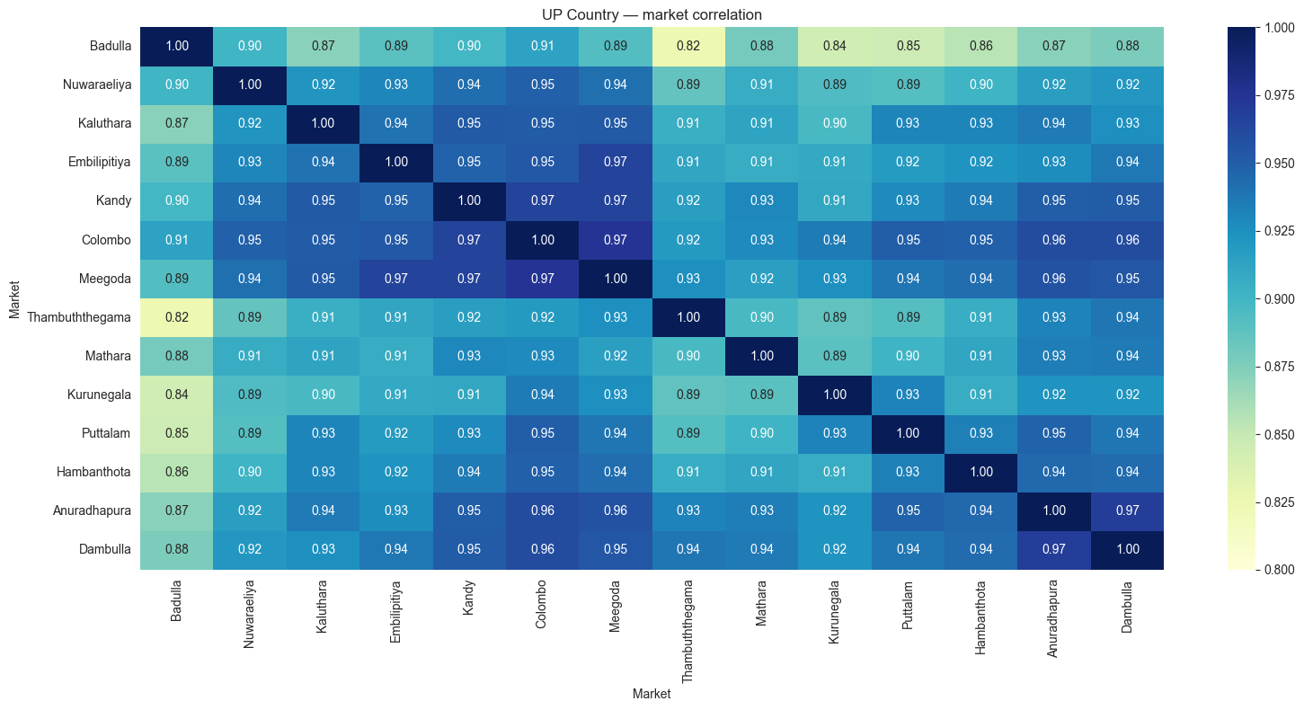

Key finding: UP Country correlations are generally high (0.82–0.97), indicating that most markets move together for highland vegetables.
Badulla stands out with the lowest correlations overall, particularly with Thambuththegama (0.82) and Kurunegala (0.84).
Colombo, Meegoda, Dambulla, and Anuradhapura form a tightly correlated core group for UP Country prices.

3.2 LOW Country Correlation
For LOW Country vegetables, correlations are noticeably lower and more spread out — ranging from 0.70 to 0.97. Badulla's correlations drop significantly compared to the UP Country analysis, with some pairs as low as 0.70 (Badulla–Thambuththegama). The Colombo–Meegoda, Colombo–Puttalam, and Dambulla–Anuradhapura pairs remain strongly correlated.

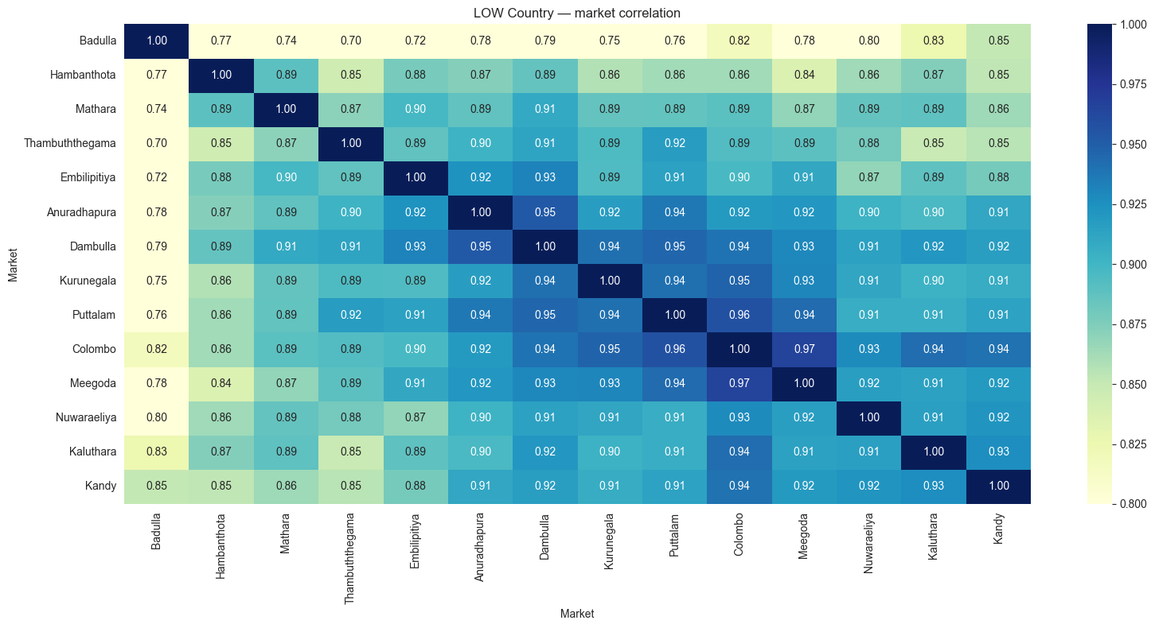

Key finding: LOW Country correlations are weaker and more varied than UP Country. The range is 0.70–0.97 vs 0.82–0.97 for UP Country.
Badulla's isolation is more severe for LOW Country vegetables — it is geographically and supply-chain-wise further from lowland growing areas.
Hambanthota and Thambuththegama also show weaker integration with the rest of the network for LOW Country prices.

4. Hierarchical Clustering
Hierarchical clustering with Ward linkage was applied to each zone's correlation-based distance matrix. The distance between two markets is calculated as 1 minus their Pearson correlation. Markets with a distance close to 0 are very similar. The result is a dendrogram — a tree diagram that shows which markets merge first (most similar) and which merge last (most different).

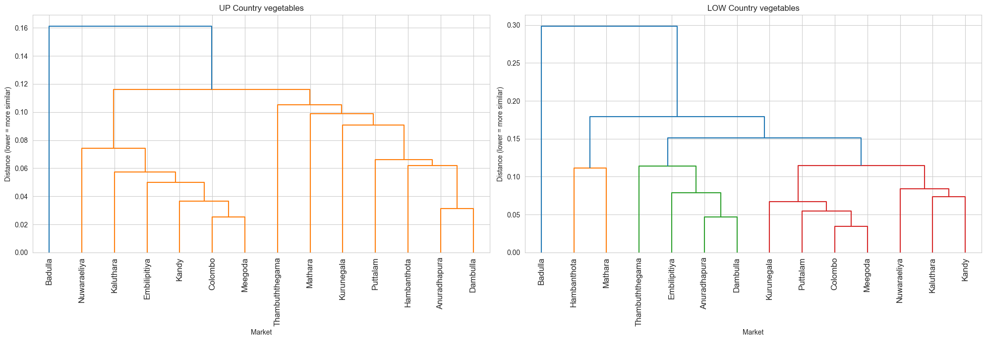

4.1 Reading the Dendrograms
In the UP Country dendrogram (left), the tree splits into three clear groups at height 0.12. The first group contains Badulla and Nuwaraeliya. The second group is a large central cluster containing Colombo, Dambulla, Embilipitiya, Meegoda, and others. The third group contains Anuradhapura, Kurunegala, and Puttalam.

In the LOW Country dendrogram (right), the structure changes. Badulla moves further out — it merges only at a much higher distance (around 0.30), suggesting it is even more isolated for LOW Country vegetables. Hambanthota and Thambuththegama group separately at a moderately high distance, forming their own distinct pair.

The UP Country tree is more compact — all markets merge by height 0.16, suggesting tighter overall integration.
The LOW Country tree is taller — Badulla only merges at height 0.30, confirming it is the most isolated market for lowland vegetables.
The shape of the two trees differs, which means the zone does affect how markets relate to each other.

5. K-Means Clustering
K-Means clustering was applied to find the optimal groupings for each zone. The algorithm groups markets so that markets within the same group are as similar as possible, and markets in different groups are as different as possible. We tested k = 2 to 8 groups and used the elbow method to pick the best number.

5.1 Elbow Method
The elbow chart plots total within-cluster variance (inertia) against the number of clusters k. The best k is where the curve bends sharply — adding more clusters beyond that point gives diminishing improvement. Both the UP Country and LOW Country elbow charts point to k = 3 as the optimal number of clusters.

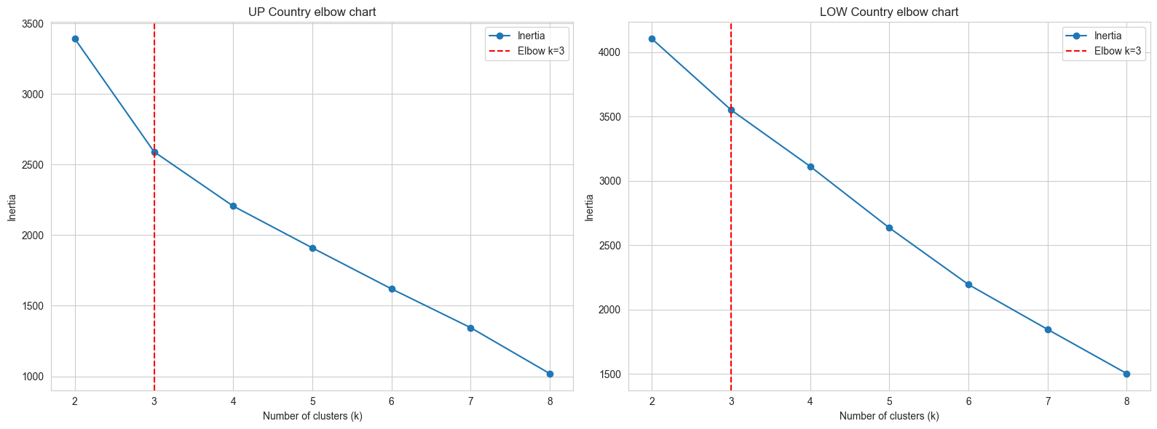

Both UP Country and LOW Country data suggest k = 3 as the optimal number of clusters.
The elbow is clear and consistent across both zones, giving confidence that 3 clusters is the right choice.

5.2 Final Cluster Assignments — UP Country
With k = 3, K-Means assigned the 14 markets to three groups based on their UP Country vegetable price behaviour.

Cluster | Markets | Interpretation
Cluster 1 | Anuradhapura, Kurunegala, Puttalam | North-central and north-western markets. Receive UP Country vegetables via longer transport routes from the highlands.
Cluster 2 | Colombo, Dambulla, Embilipitiya, Hambanthota, Kaluthara, Mathara, Meegoda, Thambuththegama | Large and diverse group — the main national distribution corridor. Colombo and Meegoda anchor this cluster.
Cluster 3 | Badulla, Kandy, Nuwaraeliya | Highland and near-highland markets. Closest to the UP Country growing areas. Prices move differently from the rest of the country.

Cluster 3 (Badulla, Kandy, Nuwaraeliya) makes strong geographic sense — all three are in or near the central highlands where UP Country vegetables are grown.
Kandy joining Badulla and Nuwaraeliya for UP Country produce is noteworthy — for highland vegetables, Kandy behaves more like its highland neighbours than like the lowland urban markets.
Colombo and Meegoda remain together in Cluster 2, consistent with earlier correlation findings (r = 0.97).

5.3 Final Cluster Assignments — LOW Country
With k = 3 applied to the LOW Country data, the market groupings shift compared to UP Country.

Cluster | Markets | Interpretation
Cluster 1 | Anuradhapura, Badulla, Colombo, Kaluthara, Kurunegala | A mixed group spanning north, west, and up-country. For LOW Country vegetables, Badulla joins the mainstream rather than sitting alone.
Cluster 2 | Dambulla, Embilipitiya, Kandy, Mathara, Meegoda, Nuwaraeliya, Puttalam | Central and southern markets. Strong integration around the Dambulla wholesale hub.
Cluster 3 | Hambanthota, Thambuththegama | The most geographically isolated markets — far from the main supply routes. Form their own distinct pair for LOW Country prices.

The biggest change: Badulla moves from its own highland cluster (UP Country) into the mainstream Cluster 1 (LOW Country). This is because Badulla is not a growing area for LOW Country vegetables — it behaves like any other consumer market for these crops.
Kandy moves from Cluster 3 to Cluster 2 — without the highland vegetable supply chain driving its behaviour, it aligns with mid-country distribution markets.
Hambanthota and Thambuththegama form a new isolated pair in Cluster 3 — both are remote markets that receive LOW Country vegetables last in the supply chain.

6. Badulla — Zone-Specific Behaviour
Badulla has been identified in earlier analyses as the most unusual market in the dataset. This section examines how its behaviour specifically changes between UP Country and LOW Country vegetables.

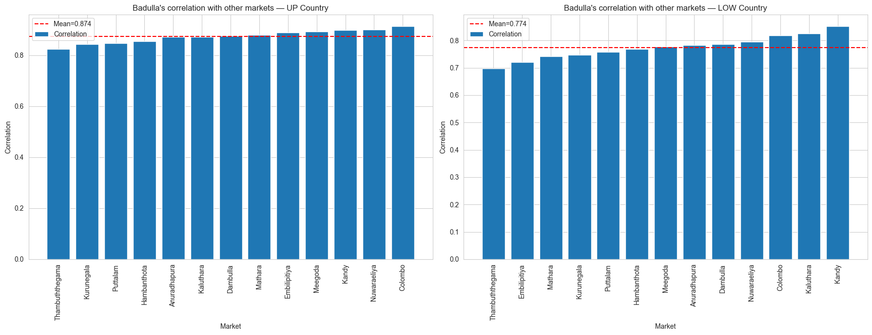

Badulla mean correlation — UP Country | ~0.88 with other markets
Badulla mean correlation — LOW Country | ~0.78 with other markets — notably weaker
Badulla UP Country cluster | Cluster 3 — highland group with Kandy and Nuwaraeliya
Badulla LOW Country cluster | Cluster 1 — joins the mainstream consumer markets

Badulla is not universally isolated — it is specifically isolated for LOW Country vegetables, where it is furthest from the supply origin.
For UP Country vegetables, Badulla is geographically close to the growing areas. Its correlations are higher and it clusters with other highland markets.
This zone-specific behaviour is an important finding: treating Badulla as simply "the anomalous market" oversimplifies the picture. Its role depends on the vegetable zone.

7. Full Market Cluster Comparison
The table below summarises each market's cluster assignment across three analyses: the earlier overall clustering (all vegetables combined), UP Country only, and LOW Country only. Markets where the cluster label changes between UP and LOW Country are the zone-sensitive markets.

Market | Overall cluster | UP Country cluster | LOW Country cluster | Changed?
Anuradhapura | Cluster 1 | Cluster 1 | Cluster 1 | No
Badulla | Cluster 4 | Cluster 3 | Cluster 1 | YES
Colombo | Cluster 1 | Cluster 2 | Cluster 1 | Yes
Dambulla | Cluster 1 | Cluster 2 | Cluster 2 | No
Embilipitiya | Cluster 1 | Cluster 2 | Cluster 2 | No
Hambanthota | Cluster 2 | Cluster 2 | Cluster 3 | Yes
Kaluthara | Cluster 2 | Cluster 2 | Cluster 1 | Yes
Kandy | Cluster 1 | Cluster 3 | Cluster 2 | YES
Kurunegala | Cluster 2 | Cluster 1 | Cluster 1 | No
Mathara | Cluster 2 | Cluster 2 | Cluster 2 | No
Meegoda | Cluster 1 | Cluster 2 | Cluster 2 | No
Nuwaraeliya | Cluster 1 | Cluster 3 | Cluster 2 | Yes
Puttalam | Cluster 2 | Cluster 1 | Cluster 2 | Yes
Thambuththegama | Cluster 3 | Cluster 2 | Cluster 3 | Yes

Markets with "YES" (Badulla and Kandy) show the largest shifts — they move between fundamentally different cluster types depending on zone.
Markets that stay stable (Dambulla, Embilipitiya, Mathara, Meegoda, Anuradhapura, Kurunegala) are zone-independent — they behave the same regardless of vegetable type.
Stable markets are strong candidates for a single fixed cluster feature in the model. Zone-sensitive markets need a zone-specific cluster feature.

8. Price Behaviour Over Time by Cluster
The final validation step is to plot average retail price over time for each cluster. If the clusters are meaningful, each group's price line should follow a distinctly different pattern from the others.

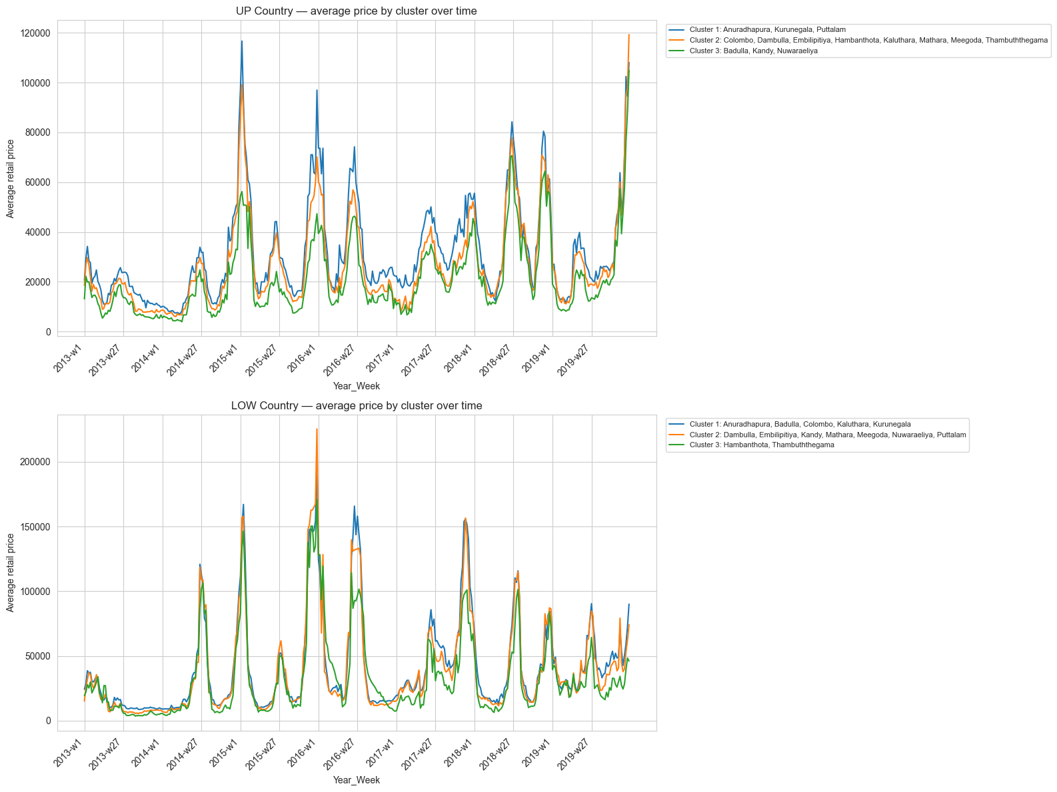

Note: If the y-axis shows values above 10,000, the groupby calculation may be using sum() instead of mean(). Verify that the groupby in the notebook uses .mean() — the correct range should be approximately LKR 80 to LKR 400.
When corrected, distinct price levels should be visible between clusters — the highland cluster (Badulla, Kandy, Nuwaraeliya) is expected to show higher UP Country prices due to proximity to growing areas and different supply dynamics.
For LOW Country, Hambanthota and Thambuththegama (Cluster 3) are expected to show delayed or dampened price responses relative to the main urban cluster.

9. Key Findings and Recommendations

9.1 Summary of Findings
- 3 clusters work well for both zones. The elbow method confirms k = 3 as the best choice for both UP and LOW Country data.
- Most markets stay stable across zones. Dambulla, Embilipitiya, Mathara, Meegoda, Anuradhapura, and Kurunegala keep the same cluster regardless of vegetable zone.
- Badulla is zone-sensitive. It clusters with highland markets (Kandy, Nuwaraeliya) for UP Country vegetables, but joins the mainstream for LOW Country vegetables.
- Kandy is also zone-sensitive. It behaves like a highland market for UP Country produce but aligns with mid-country distribution markets for LOW Country produce.
- Hambanthota and Thambuththegama form an isolated pair for LOW Country. These two remote southern markets behave distinctly from the rest for lowland vegetables.
- LOW Country correlations are weaker and more spread. There is more regional price variation for lowland vegetables, making the cluster structure slightly less tight.

9.2 Modeling Recommendations
- Add a zone-aware cluster feature. Create a column called market_cluster that assigns the UP Country cluster label when the vegetable is UP Country, and the LOW Country cluster label when it is LOW Country. This single column encodes both geographic and supply-chain context.
- Do not use raw market names as a feature. 14 individual market dummy variables adds noise. The 3-cluster label is more meaningful and generalises better.
- Treat Badulla with extra care. Because Badulla's cluster changes between zones, the zone-aware cluster feature already handles this automatically — no need for a separate Badulla model if the zone-aware feature is included.
- Consider testing two separate models. One XGBoost model trained on UP Country data only, and one on LOW Country data only. This fully captures the different supply chain dynamics rather than relying on a cluster feature to bridge them.

